# TITLE: Session Management, File handling and Error handling

# PRACTICAL -6

**Session Management, File handling and Error Handling**

**Q-1. Create a Php page which takes the student’s name and marks of three subjects from the user. Manage all information via session and display all information on the next page.**

code:

INDEX.html

<!DOCTYPE html>

<html lang="en">

<head>

<meta charset="UTF-8">

<meta name="viewport" content="width=device-width, initial-scale=1.0">

<title>Student result</title>

<style>

input{

width: 100%;

}

</style>

</head>

<body>

<form method="POST" name ="frm" action="./data1.php">

<table align="center">

<tr>

<th>Marksheet</th>

</tr>

<tr>

<td><input type="text" placeholder="Enter name" name="fname" required></td>

</tr>

<tr>

<td><input type="number" placeholder="Enter 1st subject mark" name="m1" max="100" min="0" required></td>

</tr>

<tr>

<td><input type="number" placeholder="Enter 2nd subject mark" name="m2" max="100" min="0" required></td>

</tr>

<tr>

<td><input type="number" placeholder="Enter 3rd subject mark" name="m3" max="100" min="0" required></td>

</tr>

<tr>

<td><input type="Submit" name="sbt" value="Submit"></td>

</tr>

</table>

</form>

</body>

</html>

DATA1.PHP

<?php

extract($_REQUEST);

if(isset($sbt))

{

session_start();

$_SESSION['fname']=$fname;

$_SESSION['m1']=$m1;

$_SESSION['m2']=$m2;

$_SESSION['m3']=$m3;

}

echo("name is:".$_SESSION['fname']."<br>");

echo("marks 1 is:".$_SESSION['m1']."<br>");

echo("marks 2 is:".$_SESSION['m2']."<br>");

echo("marks 3 is:".$_SESSION['m3']."<br>");

?>

OUTPUT:

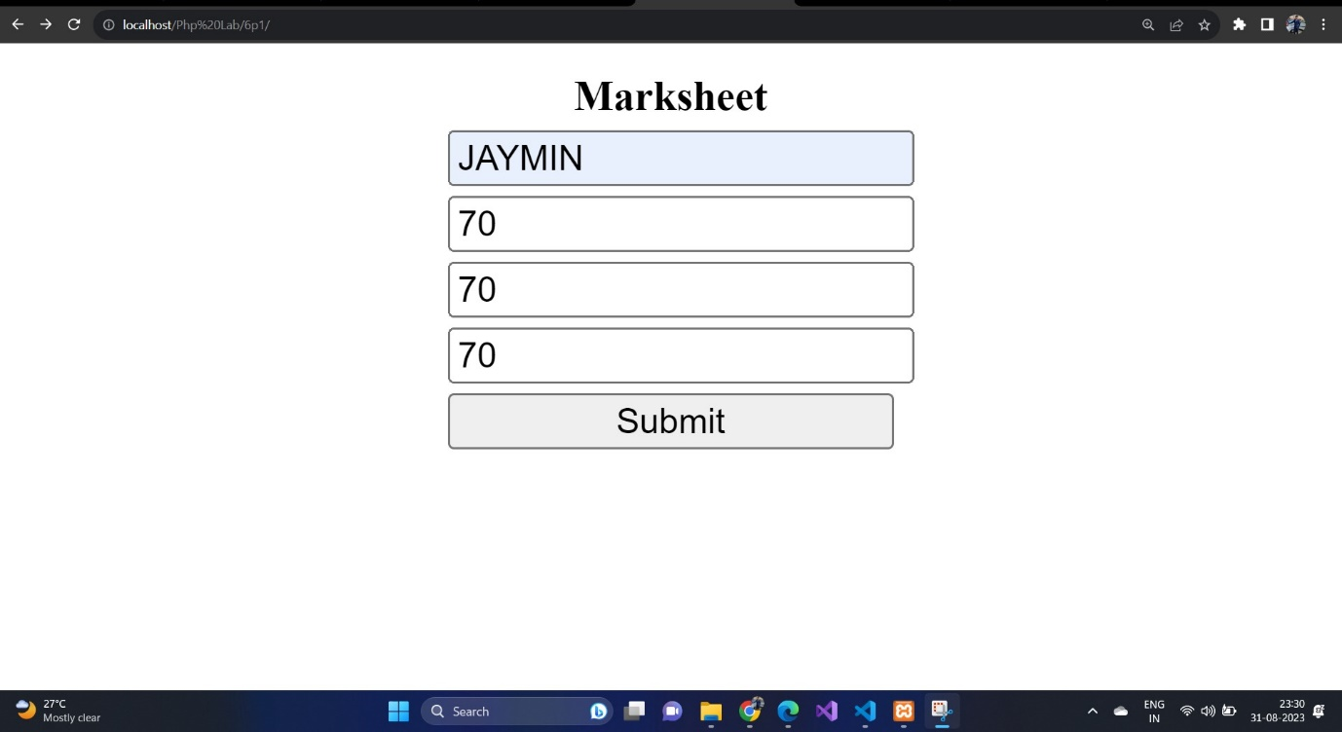

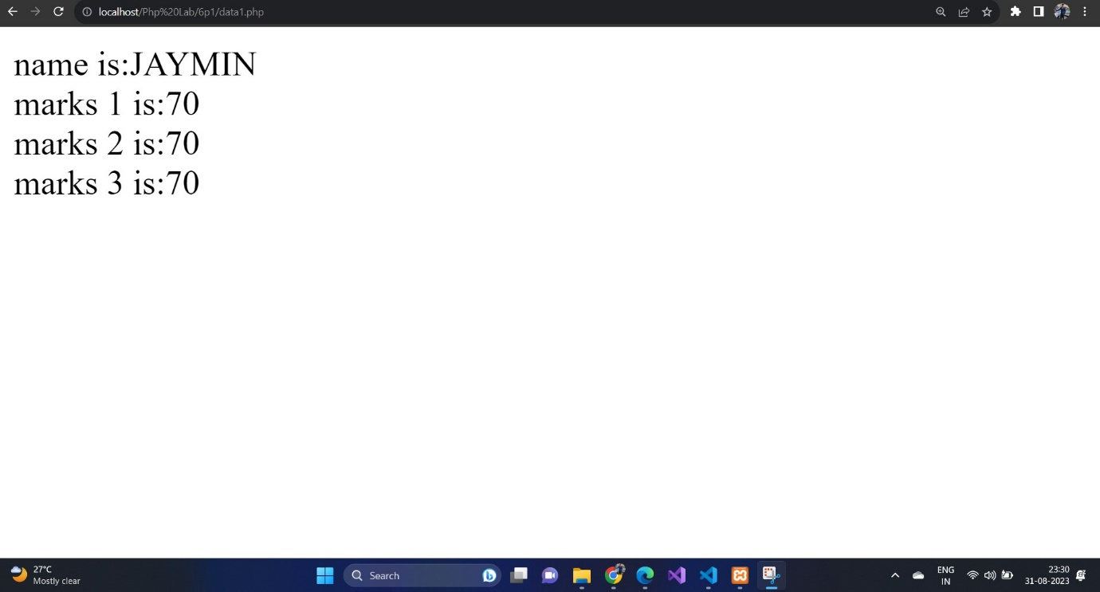

Q-2) Create php code which do following task Signup.php : take username and password

from user and select hobbies(from checkbox) & store information as session variable.

Store password in encrypted format using md5 encryption.

Viewhobbie.php : if session variable username not set display “login required”

message else display the hobbies of respective user in a well designed page.

Singout.php : clear the session variables.

Code:

Signup.php :

<?php

session_start();

if ($_SERVER['REQUEST_METHOD'] === 'POST') {

$username = $_POST['username'];

$password = md5($_POST['password']); // Encrypting the password with MD5 (not secure for production use)

$hobbies = isset($_POST['hobbies']) ? $_POST['hobbies'] : array();

$_SESSION['user_info'] = array(

'username' => $username,

'password' => $password,

'hobbies' => $hobbies

);

header('Location: viewhobbies.php');

exit();

}

?>

<!DOCTYPE html>

<html>

<head>

<title>Signup</title>

</head>

<body>

<h1>Signup</h1>

<form method="POST" action="">

<label for="username">Username:</label>

<input type="text" id="username" name="username" required><br><br>

<label for="password">Password:</label>

<input type="password" id="password" name="password" required><br><br>

<label>Hobbies:</label><br>

<input type="checkbox" name="hobbies[]" value="Reading"> Reading<br>

<input type="checkbox" name="hobbies[]" value="Gaming"> Gaming<br>

<input type="checkbox" name="hobbies[]" value="Cooking"> Cooking<br>

<input type="submit" value="Signup">

</form>

</body>

</html>

Viewhobbies.php

<?php

session_start();

if (isset($_SESSION['user_info'])) {

$username = $_SESSION['user_info']['username'];

$hobbies = $_SESSION['user_info']['hobbies'];

} else {

echo "Login required";

exit();

}

?>

<!DOCTYPE html>

<html>

<head>

<title>View Hobbies</title>

</head>

<body>

<h1>Welcome, <?php echo $username; ?></h1>

<h2>Your Hobbies:</h2>

<ul>

<?php foreach ($hobbies as $hobby) {

echo "<li>$hobby</li>";

} ?>

</ul>

</body>

</html>

Singout.php

<?php

session_start();

session_unset();

session_destroy();

header('Location: signup.php');

exit();

?>

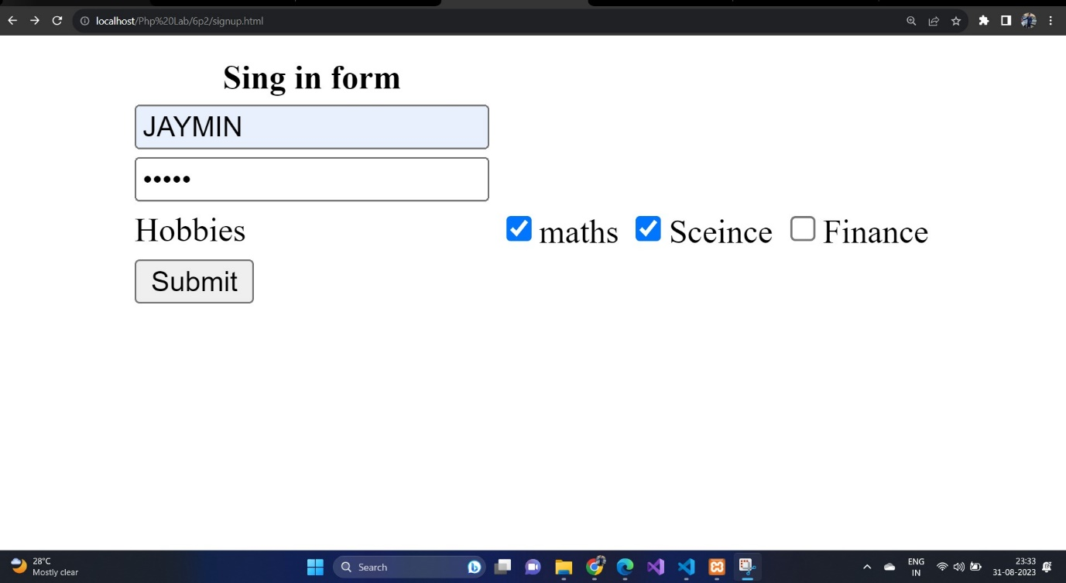



Q-3) Develop a HTML form which takes the file name and string form the user. Create a php script which creates or opens a file (if it already exists) and appends the string into the given file when the write button is clicked. On click on read button it

displays the content of the file into the browser.

Code:

Index.html:

<!DOCTYPE html>

<html>

<head>

<title>File Read/Write</title>

</head>

<body>

<h1>File Read/Write</h1>

<form method="POST" action="process.php">

<label for="filename">File Name:</label>

<input type="text" id="filename" name="filename" required><br><br>

<label for="content">Content:</label><br>

<textarea id="content" name="content" rows="4" cols="50" required></textarea><br><br>

<input type="submit" name="write" value="Write">

<input type="submit" name="read" value="Read">

</form>

</body>

</html>

PRCOCESS.PHP

<?php

if ($_SERVER['REQUEST_METHOD'] === 'POST') {

$filename = $_POST['filename'];

$content = $_POST['content'];

if (isset($_POST['write'])) {

// Open the file in append mode and write the content

$file = fopen($filename, 'a');

if ($file) {

fwrite($file, $content . "\n");

fclose($file);

echo "Content has been written to the file.";

} else {

echo "Error opening the file for writing.";

}

} elseif (isset($_POST['read'])) {

// Read the content from the file and display it

if (file_exists($filename)) {

$fileContent = file_get_contents($filename);

echo "<h2>File Content:</h2>";

echo "<pre>$fileContent</pre>";

} else {

echo "File not found.";

}

}

}

?>

OUTPUT

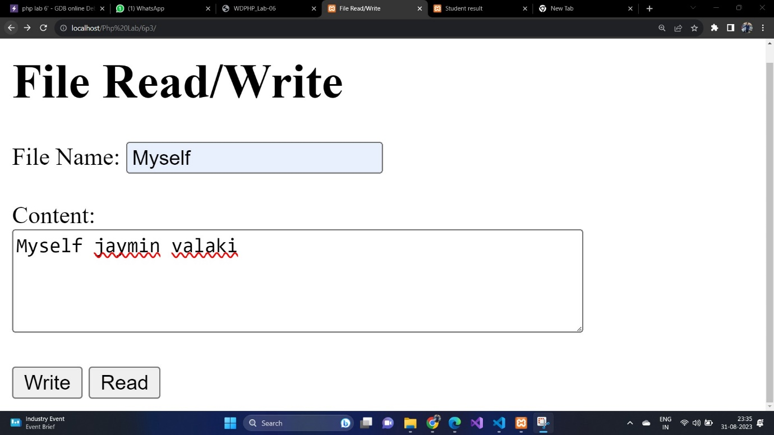

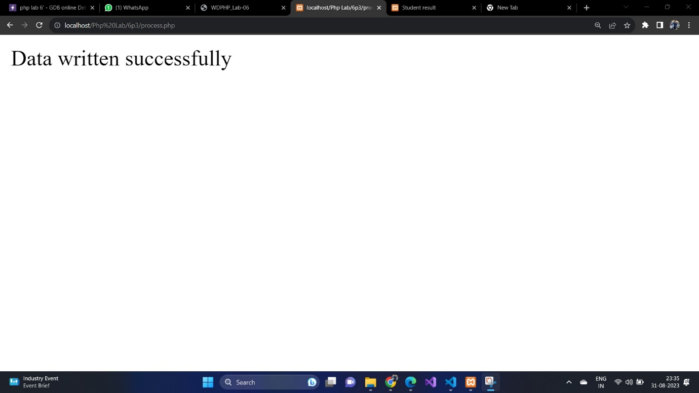

Q-4) Create a php application which has a login page, a product page, cart display page,

purchase message page and logout page. Users can login into the system using username

and password which are validated from an already stored file on the server. Once a user

is logged in successfully the user can select a product to buy and quantity to buy. User

can review the selected product with invoice details in cart page and click on buy to

purchase and can signout from application

code:

SIGNUP.PHP

<!DOCTYPE html>

<html>

<head>

<title>Sign Up</title>

</head>

<body>

<h1>Sign Up</h1>

<?php

if (isset($_GET['error'])) {

if ($_GET['error'] == 'empty') {

echo '<p style="color:red;">Please fill in all fields</p>';

} elseif ($_GET['error'] == 'user_exists') {

echo '<p style="color:red;">Username already exists</p>';

}

}

?>

<form action="register.php" method="post">

<label for="username">Username:</label>

<input type="text" id="username" name="username"><br><br>

<label for="password">Password:</label>

<input type="password" id="password" name="password"><br><br>

<input type="submit" value="Sign Up">

</form>

</body>

</html>

LOGIN.PHP

<?php

session_start();

if (isset($_SESSION['username'])) {

header('Location: product.php');

exit;

}

?>

<!DOCTYPE html>

<html>

<head>

<title>Login</title>

</head>

<body>

<h1>Login</h1>

<?php

if (isset($_GET['error'])) {

echo '<p style="color:red;">Invalid username or password</p>';

}

?>

<form action="authenticate.php" method="post">

<label for="username">Username:</label>

<input type="text" id="username" name="username"><br><br>

<label for="password">Password:</label>

<input type="password" id="password" name="password"><br><br>

<input type="submit" value="Login">

</form>

<p>Don't have an account? <a href="signup.php">Sign up</a></p>

</body>

</html>

Register.php

<?php

if (isset($_POST['username']) && isset($_POST['password'])) {

$username = $_POST['username'];

$password = $_POST['password'];

if (empty($username) || empty($password)) {

header('Location: signup.php?error=empty');

exit;

}

$users = file_get_contents('users.txt');

if (strpos($users, $username) !== false) {

header('Location: signup.php?error=user_exists');

exit;

}

file_put_contents('users.txt', "$username,$password\n", FILE_APPEND);

header('Location: login.php');

} else {

header('Location: signup.php');

}

?>

Addtocart.php

<?php

session_start();

if (!isset($_SESSION['username'])) {

header('Location: login.php');

exit;

}

if (isset($_POST['id']) && isset($_POST['quantity'])) {

$id = $_POST['id'];

$quantity = $_POST['quantity'];

if (!isset($_SESSION['cart'])) {

$_SESSION['cart'] = [];

}

if (isset($_SESSION['cart'][$id])) {

$_SESSION['cart'][$id] += $quantity;

} else {

$_SESSION['cart'][$id] = $quantity;

}

}

?>

Cart.php

<?php

session_start();

if (!isset($_SESSION['username'])) {

header('Location: login.php');

exit;

}

$products = [

['id' => 1, 'name' => 'Product 1', 'price' => 10],

['id' => 2, 'name' => 'Product 2', 'price' => 20],

['id' => 3, 'name' => 'Product 3', 'price' => 30],

];

$cart = isset($_SESSION['cart']) ? $_SESSION['cart'] : [];

$total = 0;

?>

<!DOCTYPE html>

<html>

<head>

<title>Cart</title>

</head]

<body>

<h1>Cart</h1>

<p>Welcome, <?php echo $_SESSION['username']; ?>! <a href="logout.php">Logout</a></p>

<?php if (empty($cart)): ?>

<p>Your cart is empty.</p>

<?php else: ?>

<table>

<tr>

<th>Name</th>

<th>Price</th>

<th>Quantity</th>

<th>Subtotal</th>

</tr]

<?php foreach ($cart as $id => $quantity): ?>

<?php

$product = array_filter($products, function ($p) use ($id) { return $p['id'] == $id; });

$product = array_shift($product);

$subtotal = $product['price'] * $quantity;

$total += $subtotal;

?>

<tr]

<td><?php echo $product['name']; ?></td]

<td><?php echo $product['price']; ?></td]

<td><?php echo $quantity; ?></td]

<td><?php echo $subtotal; ?></td]

</tr>

<?php endforeach; ?>

<tr>

<td colspan="3">Total</td>

<td><?php echo $total; ?></td>

</tr>

</table>

<form action="purchase.php" method="post">

<input type="submit" value="Checkout">

</form>

<?php endif; ?>

<p><a href="product.php">Continue Shopping</a></p>

</body>

</html>

Autenticate.php

<?php

session_start();

if (isset($_POST['username']) && isset($_POST['password'])) {

$username = $_POST['username'];

$password = $_POST['password'];

$users = file_get_contents('users.txt');

$users = explode("\n", $users);

foreach ($users as $user) {

list($u, $p) = explode(',', $user);

if ($u == $username && $p == $password) {

$_SESSION['username'] = $username;

header('Location: product.php');

exit;

}

}

header('Location: login.php?error=1');

} else {

header('Location: login.php');

}

?>

Products.php

<?php

session_start();

if (!isset($_SESSION['username'])) {

header('Location: login.php');

exit;

}

$products = [

['id' => 1, 'name' => 'Product 1', 'price' => 10],

['id' => 2, 'name' => 'Product 2', 'price' => 20],

['id' => 3, 'name' => 'Product 3', 'price' => 30],

];

?>

<!DOCTYPE html>

<html>

<head>

<title>Products</title>

</head>

<body>

<h1>Products</h1>

<p>Welcome, <?php echo $_SESSION['username']; ?>! <a href="logout.php">Logout</a></p>

<table>

<tr>

<th>Name</th>

<th>Price</th>

<th>Quantity</th>

<th></th>

</tr>

<?php foreach ($products as $product): ?>

<tr>

<td><?php echo $product['name']; ?></td>

<td><?php echo $product['price']; ?></td>

<td><input type="number" id="quantity-<?php echo $product['id']; ?>" value="1"></td>

<td><button onclick="addToCart(<?php echo $product['id']; ?>)">Add to Cart</button></td>

</tr>

<?php endforeach; ?>

</table>

<p><a href="cart.php">View Cart</a></p>

<script>

function addToCart(id) {

var quantity = document.getElementById('quantity-' + id).value;

var xhr = new XMLHttpRequest();

xhr.onreadystatechange = function() {

if (this.readyState == 4 && this.status == 200) {

alert('Product added to cart');

}

};

xhr.open('POST', 'add_to_cart.php', true);

xhr.setRequestHeader('Content-type', 'application/x-www-form-urlencoded');

xhr.send('id=' + id + '&quantity=' + quantity);

}

</script>

</body>

</html>

Purchase.php

<?php

session_start();

if (!isset($_SESSION['username'])) {

header('Location: login.php');

exit;

}

unset($_SESSION['cart']);

?>

<!DOCTYPE html>

<html>

<head>

<title>Purchase</title>

</head>

<body>

<h1>Purchase</h1>

<p>Welcome, <?php echo $_SESSION['username']; ?>! <a href="logout.php">Logout</a></p>

<p>Thank you for your purchase!</p>

<p><a href="product.php">Continue Shopping</a></p>

</body>

</html>

Logout.php

<?php

session_start();

session_destroy();

header('Location: login.php');

?>

OUTPUT

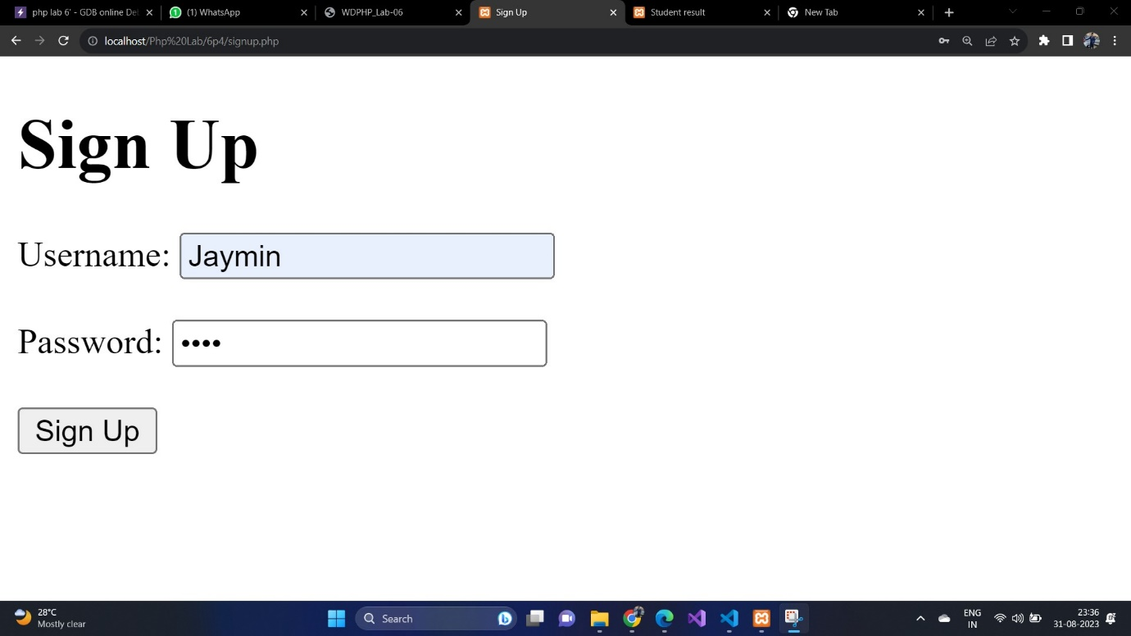

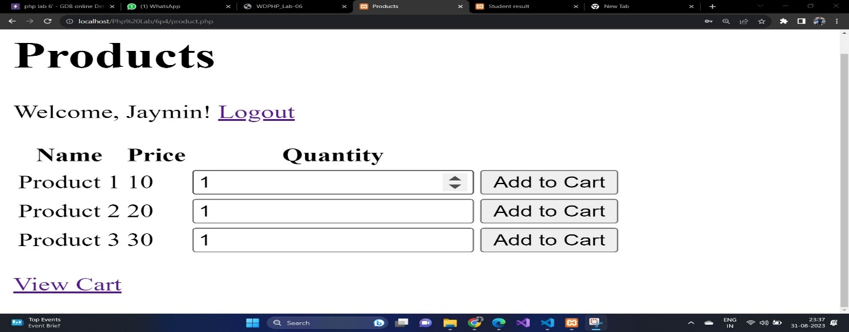

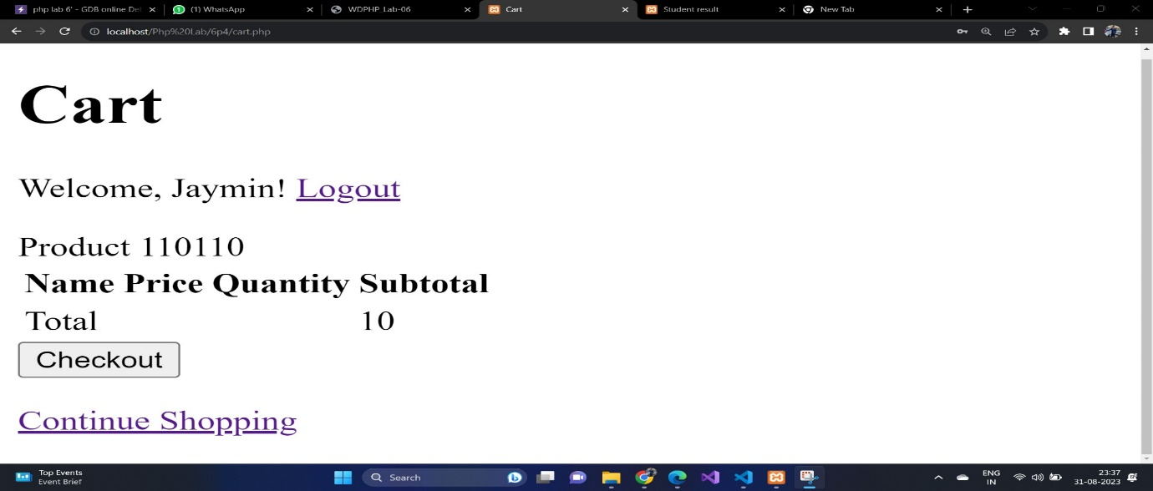

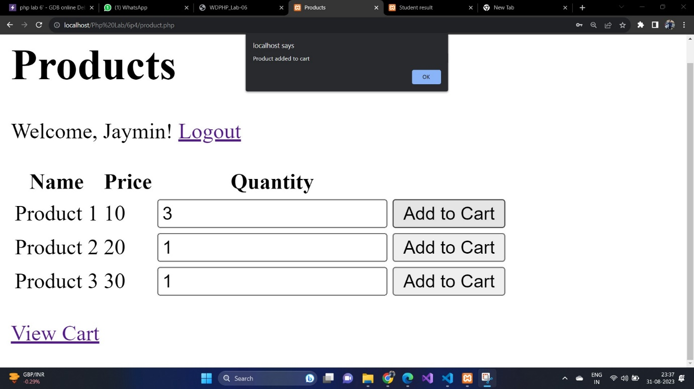

Q-5) Develop a PHP form to get students marks of 5 subjects and generate results. Take the following inputs: Exam No, Course (Drop Down), Student photo and Semester. The photo should not be greater than 25 kb in size and must be in JPEG format. Check

necessary validation and provide the option to upload the photograph on click on

upload button. Display the rest of the detail on the browser on click on submit button.

Code :

Index.html

<!DOCTYPE html>

<html>

<head>

<title>Student Result</title>

</head>

<body>

<h1>Student Result</h1>

<form method="POST" action="process.php" enctype="multipart/form-data">

<label for="exam_no">Exam No:</label>

<input type="text" id="exam_no" name="exam_no" required><br><br>

<label for="course">Course:</label>

<select id="course" name="course">

<option value="Math">Math</option>

<option value="Science">Science</option>

<option value="History">History</option>

</select><br><br>

<label for="photo">Student Photo (JPEG, max 25KB):</label>

<input type="file" id="photo" name="photo" accept="image/jpeg" required><br><br>

<label for="semester">Semester:</label>

<input type="text" id="semester" name="semester" required><br><br>

<input type="submit" name="submit" value="Submit">

</form>

</body>

</html>

Data.php

<?php

if ($_SERVER['REQUEST_METHOD'] === 'POST') {

$examNo = $_POST['exam_no'];

$course = $_POST['course'];

$semester = $_POST['semester'];

// Get student marks from form input

$subject1 = $_POST['subject1'];

$subject2 = $_POST['subject2'];

$subject3 = $_POST['subject3'];

$subject4 = $_POST['subject4'];

$subject5 = $_POST['subject5'];

// Calculate total and average marks

$totalMarks = $subject1 + $subject2 + $subject3 + $subject4 + $subject5;

$averageMarks = $totalMarks / 5;

$photoFile = $_FILES['photo'];

$photoName = $photoFile['name'];

$photoSize = $photoFile['size'];

$photoTmpName = $photoFile['tmp_name'];

if ($photoSize > 25600) { // 25KB in bytes

echo "Error: Photo size exceeds 25KB.";

exit();

}

if (!move_uploaded_file($photoTmpName, "photos/$photoName")) {

echo "Error uploading photo.";

exit();

}

}

?>

<!DOCTYPE html>

<html>

<head>

<title>Student Result</title>

</head>

<body>

<h1>Student Result</h1>

<h2>Exam No: <?php echo htmlspecialchars($examNo); ?></h2>

<p>Course: <?php echo htmlspecialchars($course); ?></p>

<p>Semester: <?php echo htmlspecialchars($semester); ?></p>

<img src="photos/<?php echo htmlspecialchars($photoName); ?>" alt="Student Photo"><br><br>

<!-- Display student marks and result -->

<p>Subject 1: <?php echo htmlspecialchars($subject1); ?></p>

<p>Subject 2: <?php echo htmlspecialchars($subject2); ?></p>

<p>Subject 3: <?php echo htmlspecialchars($subject3); ?></p>

<p>Subject 4: <?php echo htmlspecialchars($subject4); ?></p>

<p>Subject 5: <?php echo htmlspecialchars($subject5); ?></p>

<p>Total Marks: <?php echo htmlspecialchars($totalMarks); ?></p>

<p>Average Marks: <?php echo htmlspecialchars($averageMarks); ?></p>

<a href="index.php">Back to Form</a>

</body>

</html>

OUTPUT:

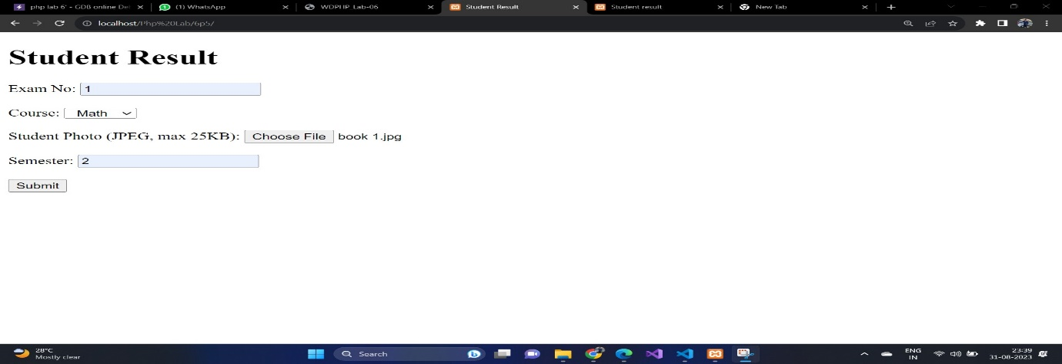

Q-6) Create a Php script to demonstrate different types of errors.(Notice, warning, error)

Code:

Index.php

<?php

// Notice Error

$variable1 = 5;

echo $variable1; // This will work fine

echo $variable2; // This will generate a notice error because $variable2 is not defined

// Warning Error

$file = fopen("nonexistent_file.txt", "r"); // This will generate a warning error because the file does not exist

// Error

function divide($a, $b) {

return $a / $b;

}

$result = divide(10, 0); // This will generate a division by zero error

echo "This will not be displayed because of the error above.";

error_reporting(E_ALL & ~E_NOTICE);

ini_set('display_errors', 1);

$x = $undefined_variable;

?>

OUTPUT

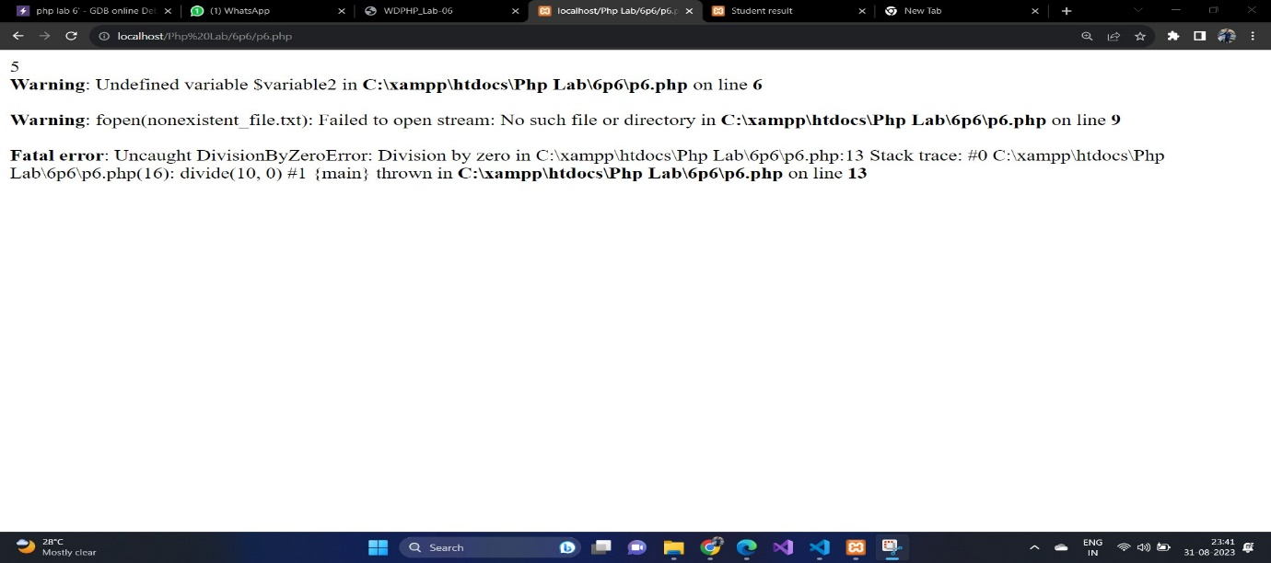

Q-7) Create PHP script for a custom error handling function in which two parameters are passed. If the first parameter is less than the second parameter then it should display a warning. If any of the parameters is not a number then it should generate fatal error

Code:

<?php

function customErrorHandler($errno, $errstr, $errfile, $errline) {

switch ($errno) {

case E_USER_WARNING:

echo "User Warning: $errstr<br>";

break;

case E_USER_ERROR:

echo "User Error: $errstr<br>";

die();

default:

echo "Unknown error type: $errstr<br>";

break;

}

}

set_error_handler("customErrorHandler");

function checkParameters($param1, $param2) {

if (!is_numeric($param1) || !is_numeric($param2)) {

trigger_error("Fatal Error: Parameters must be numbers", E_USER_ERROR);

}

if ($param1 < $param2) {

trigger_error("Warning: Parameter 1 is less than Parameter 2", E_USER_WARNING);

}

echo "Parameters are valid."; }

checkParameters(5, 10); // No errors or warnings

checkParameters("abc", 10); // Fatal error

checkParameters(15, 8); // Warning

?>

OUTPUT:

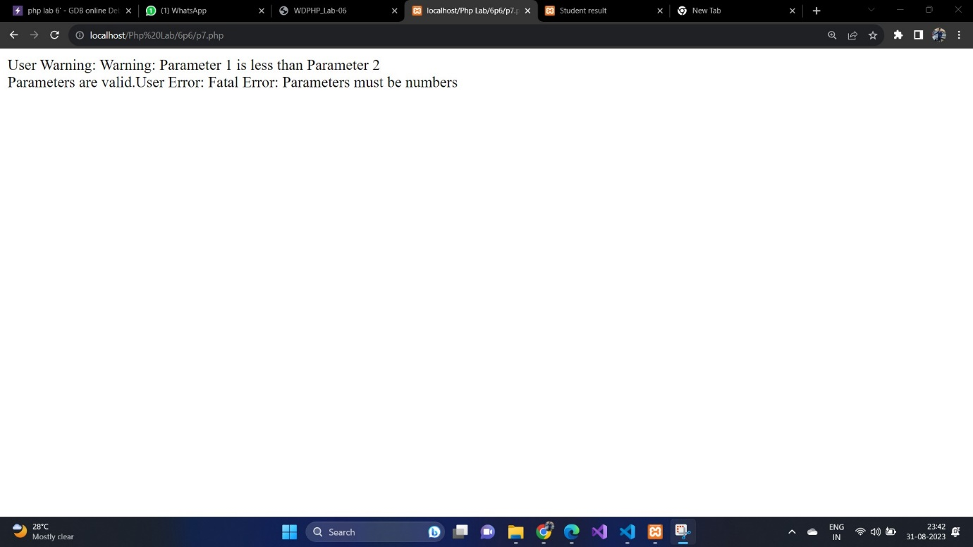

Q-8) Create a Php script which triggers an error/warning if the number entered by the user is negative with an appropriate message.

Code:

<!DOCTYPE html>

<html>

<head>

<title>Negative Number Check</title>

</head>

<body>

<h1>Negative Number Check</h1>

<form method="POST" action="">

<label for="number">Enter a number:</label>

<input type="number" id="number" name="number" required>

<input type="submit" value="Check">

</form>

</body>

</html>

<?php

function customErrorHandler($errno, $errstr, $errfile, $errline) {

echo "Error: $errstr<br>";

}

set_error_handler("customErrorHandler");

if ($_SERVER['REQUEST_METHOD'] === 'POST') {

$number = $_POST['number'];

if ($number < 0) {

trigger_error("Negative numbers are not allowed.", E_USER_WARNING);

}

}

?>

OUTPUT:

